**A L MA W A K E B A L B A R SH A**

**MO D E L U N I T E D N A T I O N S**

International Atomic Energy Agency (IAEA)

***Background Guide***

**CHAIR:**

Rabab Helal [rabab.helal@amb.sch.ae](mailto:rabab.helal@amb.sch.ae)

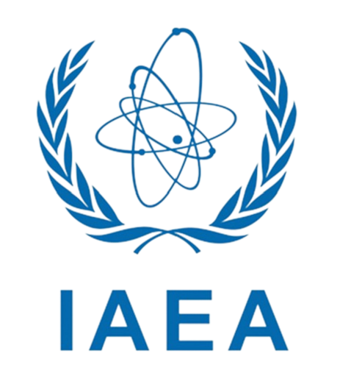

**CHAIR:** Tia Koulaylat [tia.koulaylat@amb.school.ae](mailto:tia.koulaylat@amb.school.ae)

**CO-CHAIR:** Majid Abbas

[majid.abbas@amb.sch.ae](mailto:majid.abbas@amb.sch.ae)

**International Atomic Energy Agency**

The International Atomic Energy Agency (IAEA) is a prominent international agency within the United Nations system that was founded in 1957 to promote international cooperation in the secure and non-violent application of nuclear energy. Since December 2009, the IAEA has served as an intergovernmental forum, fostering scientific and technological collaboration among its 164 Member States and various collaborators across the globe. The agency seeks to enhance the humanitarian advantages of nuclear technology alongside guaranteeing its peaceful deployment. The IAEA aids its Member States by advocating the reliable and safe application of nuclear energy while promoting the transfer of scientific and technical knowledge through efforts that include technical collaboration.

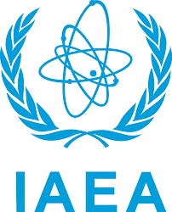

**Introduction to the topic**

The threat of a potential Nuclear War is a complex and grave issue that begins with the development of nuclear weaponary in the 20th century amidst World War II. Following the World War, further geopolitical conflicts lead to an increase in nuclear weapon research world-wide, furthering the threat of a deleterious international Nuclear War.

Early in 1939, the world's scientific community discovered that German physicists had learned the secrets of splitting a uranium atom. Fears soon spread over the possibility of Nazi scientists utilizing that energy to produce a bomb capable of unspeakable destruction. Uneasiness regarding the risks of such discoveries was not shared by many, but scientists such as Einstein brought attention to the topic, urging President Roosevelt to launch a project focusing on such weaponary. The request was approved, and in late 1941, the "Manhattan Project" began – the code name for a top secret operation employing over 120 000 American citizens in the pursuit of nuclear weaponary.

In 1945, these efforts proved to be successful, and the first atomic bomb was viably tested. On August 6th of that same year, the first nuclear bomb ever used in warfare was dropped on Hiroshima, Japan; and 3 days later, on August 9th, a second nuclear bomb was detonated over Nagasaki, Japan. These two events mark the only usages of atomic bombs in warfare, and the bombs' detonation led to the end of World War II upon Japan's surrender on September 2nd of that same year.

Upon the conclusion of the Second World War, a war of ideologies between the Soviet Union and the United States of America began; two rising world powers amidst the post-war unrest and destruction, competing over the domination of world resources and influence. Also known as the Cold War, a major aspect of this conflict was the Nuclear Arms Race, which involved engagement in the development of powerful and sophisticated nuclear arsenals by both nations. Following the USA's success in designing the first atomic bomb in 1945, the Soviet Union found success just four years later, and the United Kingdom, France, China, and other nations soon followed.

**Past actions**

Several key treaties have been established to address nuclear arms control, aiming to limit the proliferation of nuclear weapons, reduce arsenals, and promote global security. Some of the notable treaties include:

**1. Nuclear Non-Proliferation Treaty (NPT):**

Established in 1968, this treaty’s objective was to prevent the spread of nuclear weapons and technology, promote peaceful uses of nuclear energy, and work towards nuclear disarmament. It divides nations into nuclear-armed and non-nuclear-armed states, with nuclear-armed states committing to eventual disarmament, and non-nuclear-armed states committing to remain as such.

**2. Strategic Arms Reduction Treaty (START I):**

In 1991, this treaty was established to limit and reduce the strategic nuclear arms of the United States and the Soviet Union. It played a significant role in the post-Cold War reduction of nuclear arsenals by limiting deployed strategic nuclear weapons and delivery vehicles.

**3. New START (Strategic Arms Reduction Treaty):**

This treaty was created In 2010 to further reduce and limit US and Russian strategic nuclear arsenals.It imposes limits on deployed strategic nuclear warheads and delivery systems. It was an extension of previous START treaties and was in force until 2021.

Other treaties have also been established – some ratified, and some not – in order to ensure global security regarding this grave matter. Progress, however, is largely dependent on individual nations' willingness to engage in arms control measures and pursue disarmament, and such treaties are often abandoned.

**Current Situation**

The escalating tensions between major nuclear powers have reignited concerns about the possibility of a nuclear conflict. Presently, there are approximately 13,080 nuclear warheads globally, with the United States and Russia possessing over 90% of these. The recent years have seen a significant deterioration in diplomatic relations, increasing the risk of miscalculation or accidental launches. In 2022, the Doomsday Clock, a symbolic indicator of global vulnerability to catastrophe, was set at 100 seconds to midnight, reflecting the heightened nuclear risk.

The potential humanitarian impact of a nuclear war is catastrophic. Studies estimate that even a limited nuclear exchange could cause up to 2 billion deaths, primarily due to global climate changes and crop failures. This "nuclear famine" scenario, as outlined by researchers, suggests that the resulting soot and smoke from urban fires would significantly disrupt the global climate, reducing sunlight and lowering temperatures. This climatic shift could lead to a decrease in global food production by 10-20% over 5-10 years, exacerbating the existing food insecurity issues affecting over 821 million people worldwide.

On the health front, the immediate effects of a nuclear explosion are devastating. A single nuclear bomb detonated over a large city could kill millions. The explosion of a 100-kiloton bomb, which is smaller than many in current arsenals, would instantly kill an estimated 1.3 million people and injure another 1.6 million. Long-term effects include increased cancer risks and genetic damage across generations. The World Health Organization has warned that the health systems would be overwhelmingly incapacitated, unable to provide adequate care to the survivors.

Furthermore, the psychological impact on survivors and the global population would be profound, with an increase in mental health disorders such as PTSD, anxiety, and depression. Economically, the aftermath of a nuclear explosion would lead to an estimated cost of over 1 trillion USD in immediate damages and trillions more in long-term economic impact. This scenario would severely hinder global economic recovery efforts, particularly in the wake of recent global crises. In summary, the threat of nuclear war poses an unparalleled risk to humanity, with irreversible consequences on health, environment, and global stability.

**Questions a resolution must answer**

* Who is held responsible for the catastrophic nuclear war and its humanitarian impact?
* What measures can be established to prevent the threat of nuclear war?
* What solutions can we come up with to limit nuclear war?
* What measures can be established to stop politics from impeding aid to countries struggling with humanitarian impact ?
* How can the global community work together to prevent a nuclear war and minimize its humanitarian impact? Discuss diplomatic, disarmament, and humanitarian strategies for safeguarding peace and protecting civilian populations.